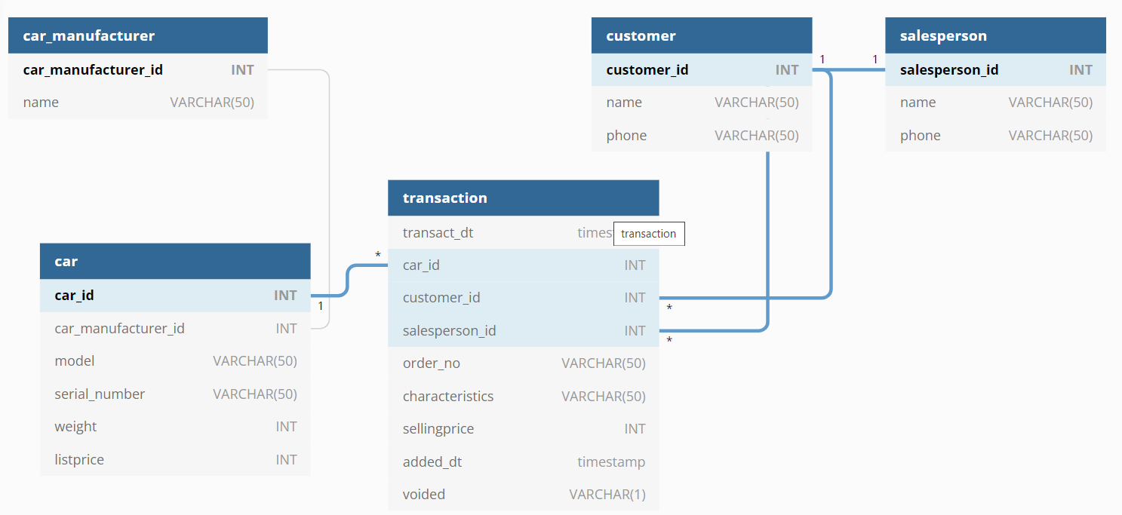

Table : public.car_manufacturer

|  |  |  |  |
| --- | --- | --- | --- |
| Field Name | Type | Length | Remarks |
| car_manufacturer_id | INT |  | Primary Key |
| name | VARCHAR | 50 | Unique |

Table : public.car

|  |  |  |  |
| --- | --- | --- | --- |
| Field Name | Type | Length | Remarks |
| car_id | INT |  | Primary Key |
| car_manufacturer_id | INT |  | Foreign Key |
| model | VARCHAR | 50 |  |
| serial_number | VARCHAR | 50 |  |
| weight | INT |  |  |
| listprice | INT |  |  |

Table : public.customer

|  |  |  |  |
| --- | --- | --- | --- |
| Field Name | Type | Length | Remarks |
| customer_id | INT |  | Primary Key |
| name | VARCHAR | 50 |  |
| phone | VARCHAR | 50 |  |

Table : public.salesperson

|  |  |  |  |
| --- | --- | --- | --- |
| Field Name | Type | Length | Remarks |
| salesperson_id | INT |  | Primary Key |
| Name | VARCHAR | 50 |  |
| Phone | VARCHAR | 50 |  |

Table : public.transaction

|  |  |  |  |
| --- | --- | --- | --- |
| Field Name | Type | Length | Remarks |
| transact_dt | timestamp |  |  |
| car _id | INT |  | Foreign Key |
| customer_id | INT |  | Foreign Key |
| salesperson_id | INT |  | Foreign Key |
| order_no | VARCHAR | 50 | Unique |
| characteristics | VARCHAR | 50 |  |
| sellingprice | INT |  |  |
| added_dt | timestamp |  | Default is system date time |
| voided | VARCHAR | 1 | Default is N |